Week 4 Exercise
Objective 1: Conceptual Foundation

Apache Spark is a widely used big data framework. At its core, spark enhances data processing. The driver (coordinator) is Spark Context. It plugs into different cluster managers such as yarn or Kubernetes. The manager decides how CPU and ram is assigned. Finally, the worker nodes run multiple tasks. The cumulative architecture is that driver coordinates, the manager distributes resources, and the executors run the tasks.
RDD is a fundamental concept to spark. RDD stands for resilient distributed dataset. Simply put, RDD allows spark to operate with redundancy to make the data fault tolerant. DAG executes your code across the structure. Spark itself WILL NOT execute until you call the execute command. This is ideal because it allows Spark to be “lazy” and formula a plan for the command across the cluster. A DAG is constructed which executes the code across the cluster. There is also in memory processing. This means that data is retained within memory, allowing spark to massively outperform MapReduce.
Past exercises used Hadoop map reduce. Compared to Spark, Map Reduce required reading/writing to disks whereas Spark did most of the work in memory. Spark’s memory utilization saves resources and speeds up performance. If it feels like Spark is doing things smarter, it’s because Hadoop/MapReduce are 1st generation computing whereas Spark is 2nd generation.

Objective 2 – Running SparkPi with PySpark
This is Apache Spark execution output showing the DAG scheduler creating stages, assigning tasks to executors, and tracking each task as it runs and finishes. After all stages complete successfully, Spark shuts down the context, stops executors, and cleans up temporary resources, indicating the job ended normally without errors.
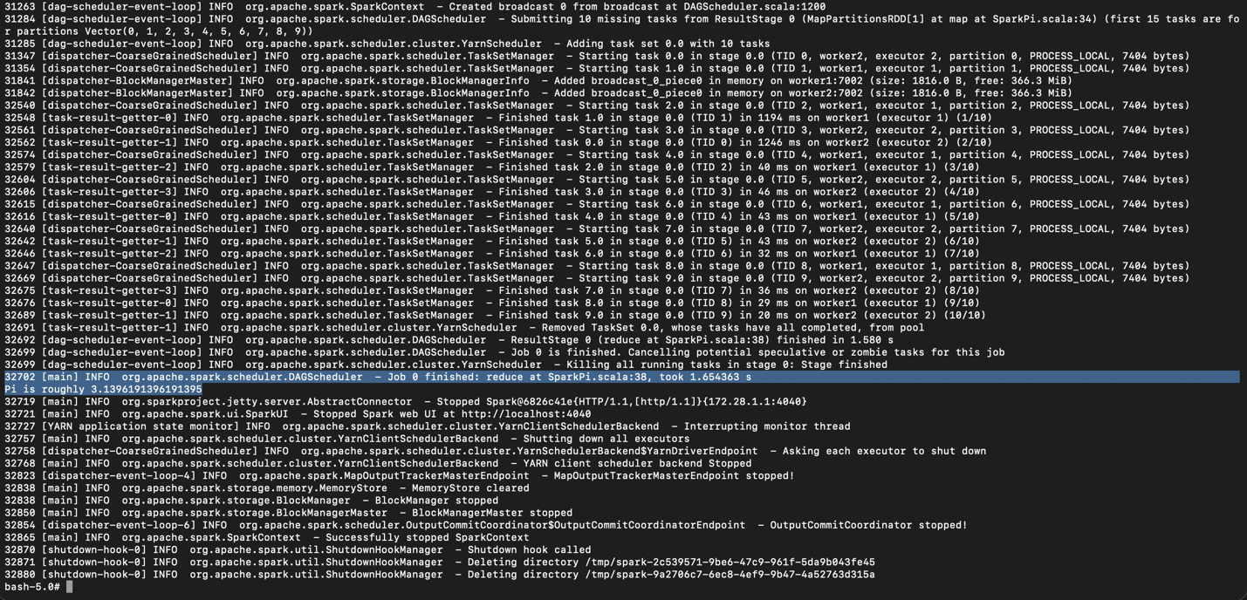

Objective 3 – Spark Scala Shell
This shows the Spark interactive shell starting up on YARN, initializing a SparkContext and SparkSession, and connecting to the Spark web UI. You then create a local Scala collection of random numbers, parallelize it into an RDD, and trigger execution with a take(100).foreach(println), which causes Spark to run a job and print the first elements.
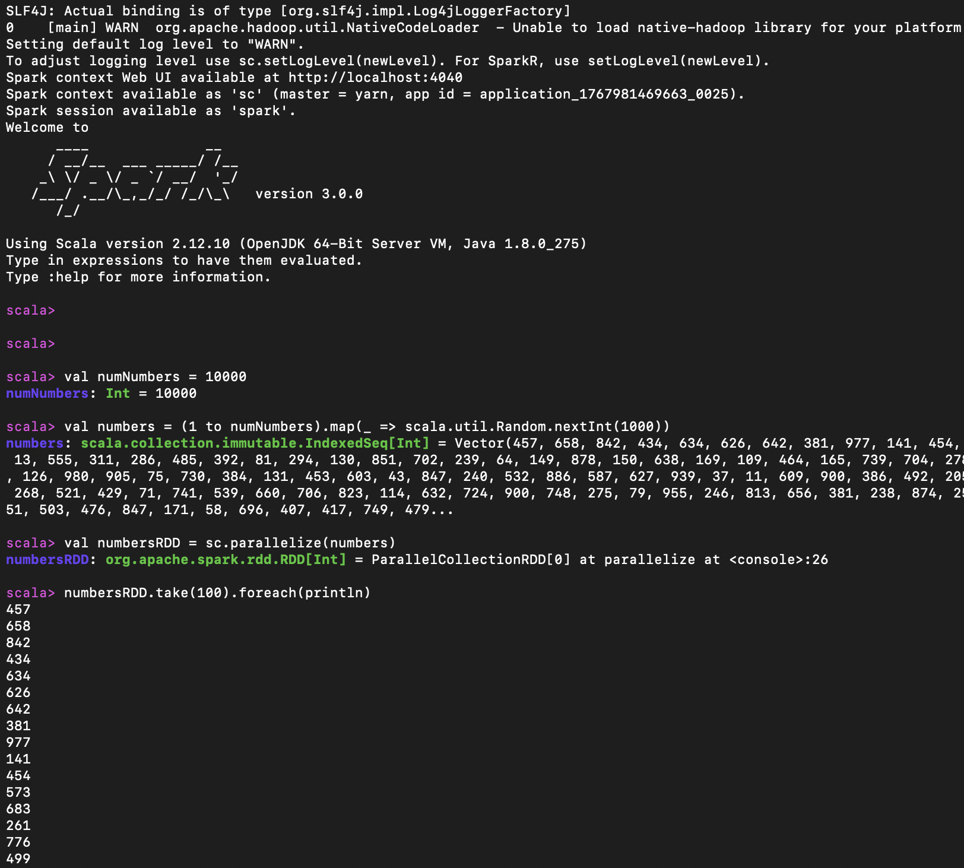

Objective 4 – Custom Transformation with Scala
This shows a Spark Scala REPL session where you generate random sentences from a word list, parallelize them into an RDD, and apply a map transformation to convert each sentence to uppercase. The final take(100).foreach(println) action triggers execution and prints the transformed results, demonstrating a basic RDD transformation and action workflow.
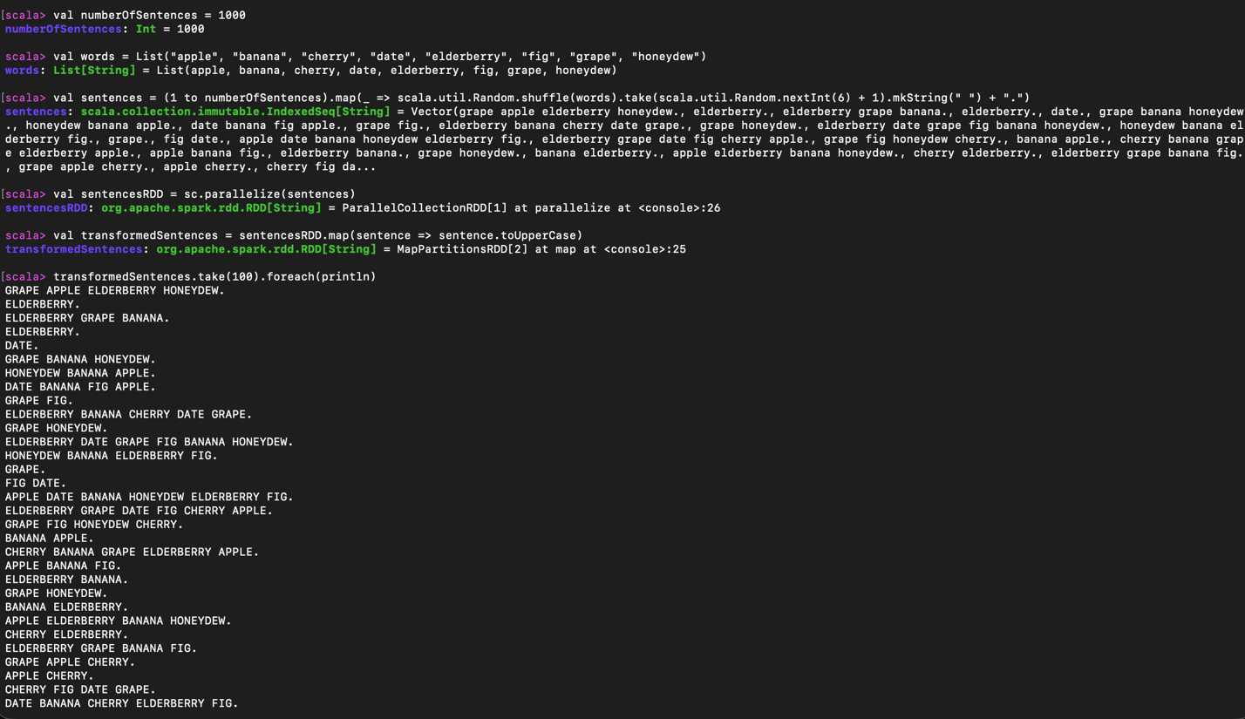

Objective 5 – Spark IDE + week4.py
This script starts a Spark session, generates 1,000 random sentences on the driver, and parallelizes them into an RDD so Spark can process them in parallel. It then applies a map transformation that converts each sentence into a tuple containing the sentence itself, the total word count, and the number of unique words, and finally triggers execution with take(100) to print sample results before shutting Spark down.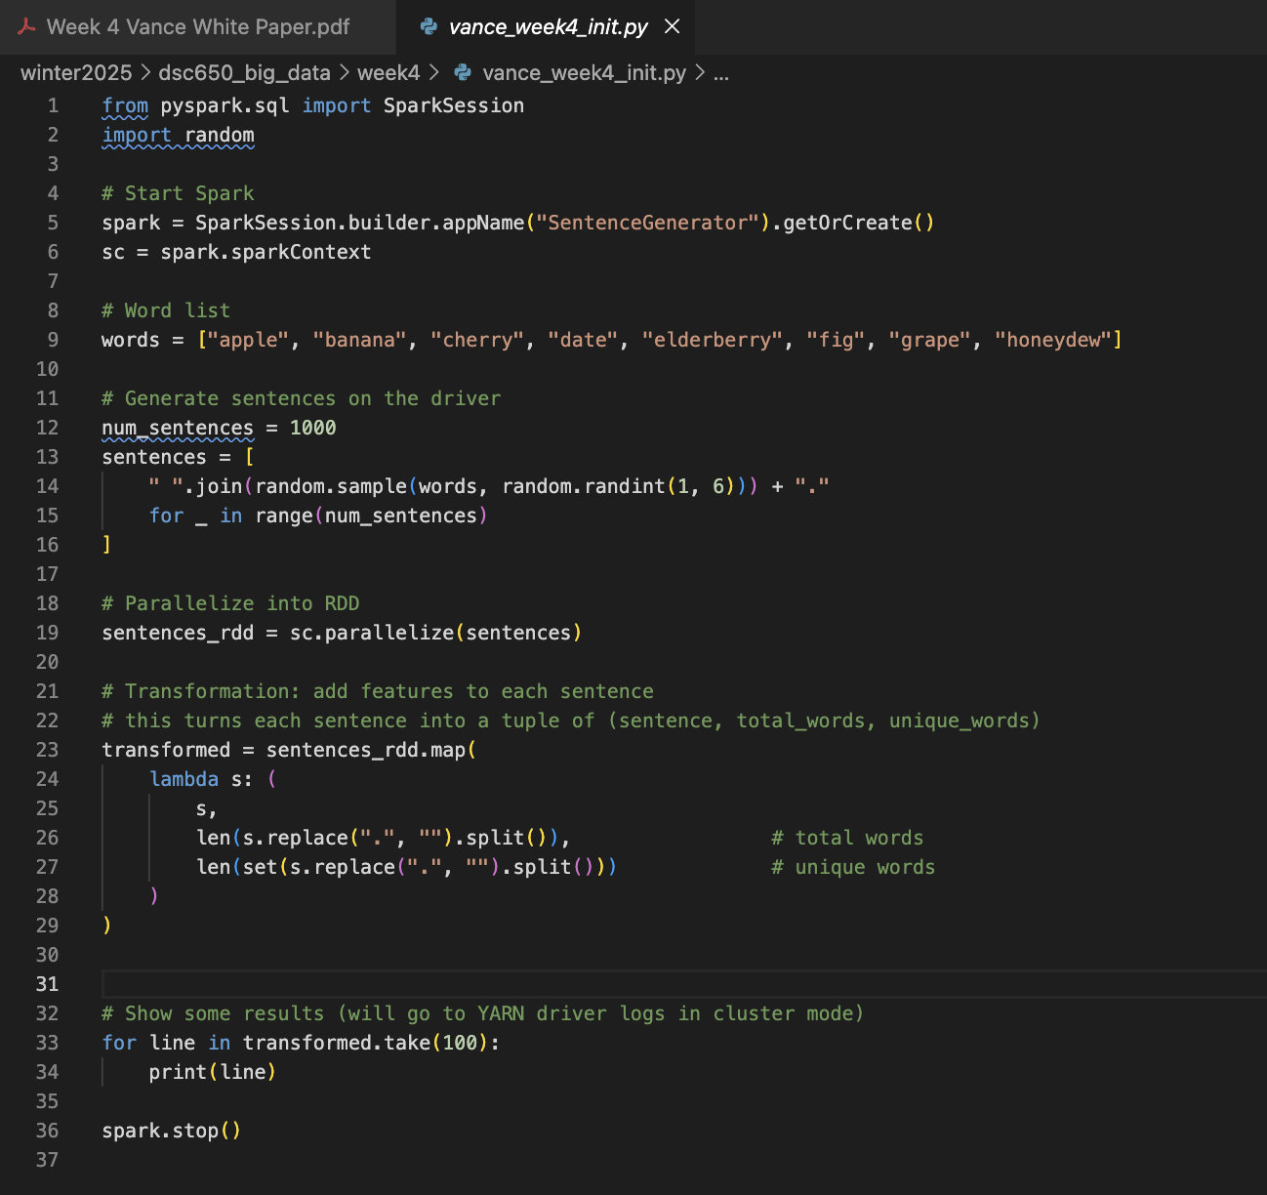

After wget’ing the file from github into the VM, we ran using spark-submit. This confirms that my Spark job actually ran inside the container without errors and that Spark was able to execute my code end to end. The output shows my sentences being processed in parallel and correctly transformed into tuples with total and unique word counts, which tells me the script was found, executed, and completed successfully.

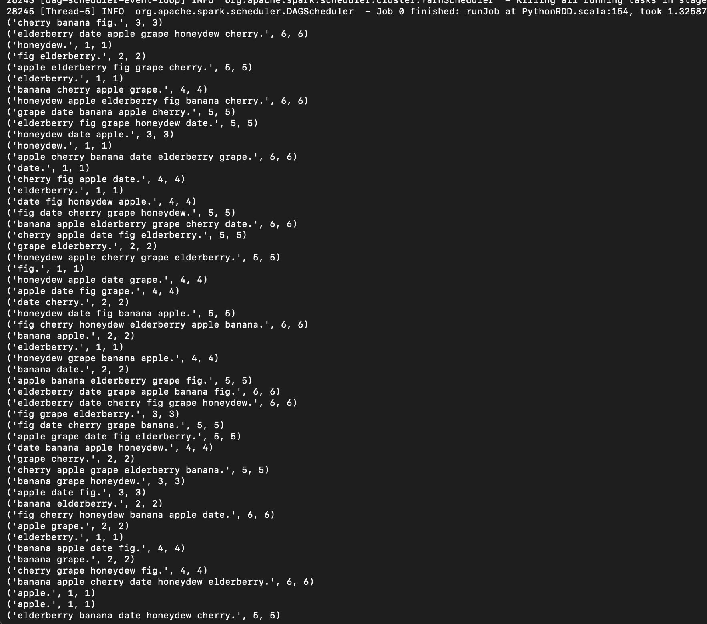

Next we can ls the tmp dir to confirm the output was saved.
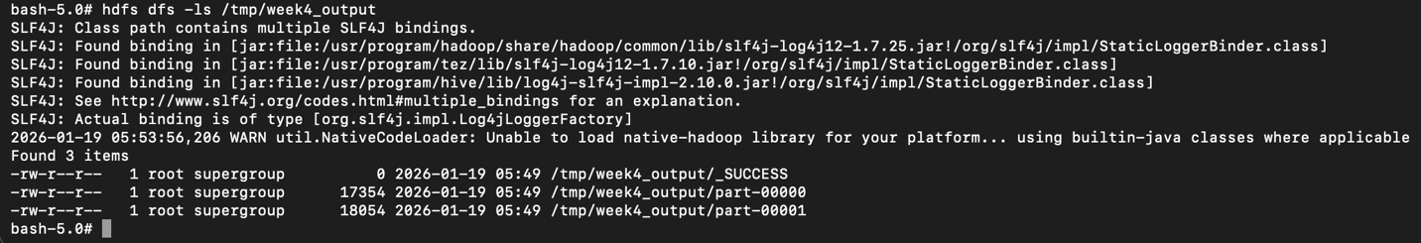
And finally we can cat the file to confirm its contents. This confirms that my Spark job successfully wrote its output to HDFS and that I can read it back from the cluster filesystem. Seeing the tuples printed by hdfs dfs -cat tells me the data was actually persisted in HDFS, not just computed in memory, so the full pipeline—Spark execution, HDFS write, and HDFS read—worked correctly inside the container.
